Computer Memory

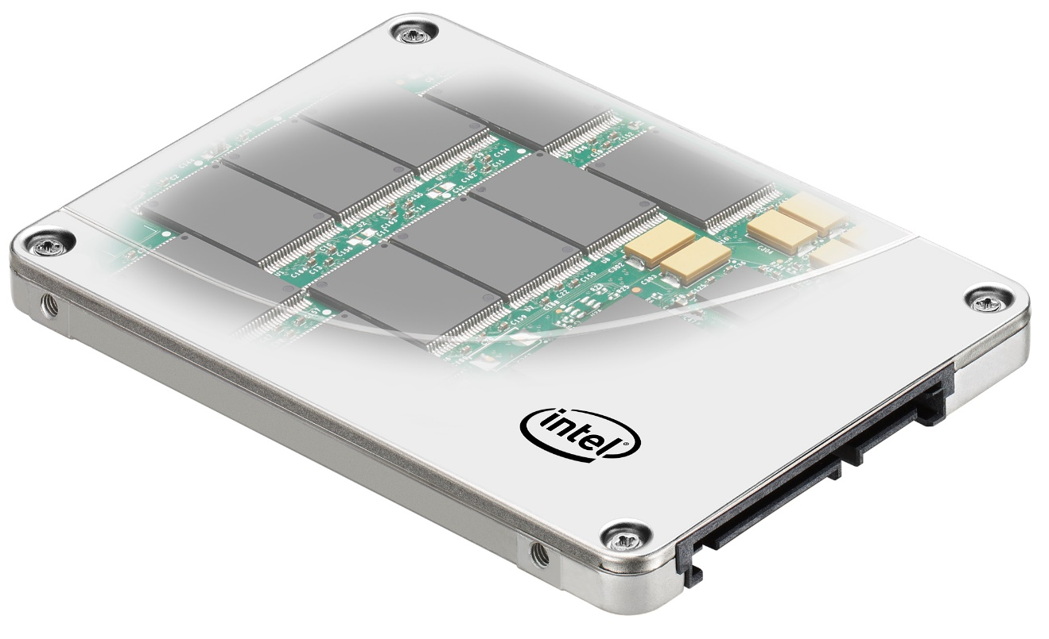

Leo Groza | Computer Hardware | 05/05/2017**Content**

Introduction………………………………………………………………………………………………………5

Primary Memory……………………………………………………………………………………………….6

RAM and ROM………………………………………………………………………………………………….6

Secondary Memory……………………………………………………………………………………………7

Hard Disk………………………………………………………………………………………………………….9

FDISK………………………………………………………………………………………………………………..11

Solid State Drives………………………………………………………………………………………………12

IDE and SATA………………………………………………………………………………………….……….14

Recap………………………………………………………………………………………………………………..14

Conclusions………………………………………………………………………………………………………15

Bibliography……………………………………………………………………………………………………..16

**Computer Memory**

**Introduction**

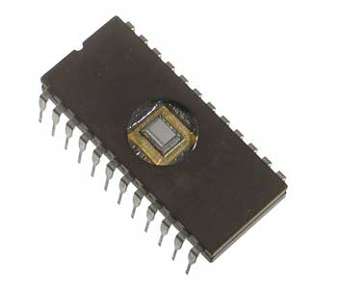 Like a human brain, the computer memory represents the internal storage of a computer, a place for storing data and instructions. Computer memory represents the place where data will be processed and where the instructions for processing data will be stored.

The word storage is used for memory that exists on tapes or disks. A memory is divided into small parts called cells and the location of each cell has a unique address. (Beal, 2017)

The computer memory can be classified on 3 parts:

* **Catch memory;**
* **Main Memory;**
* **Secondary Memory**. (Anon., 2016)

[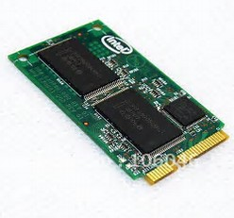](https://www.bing.com/images/search?view=detailV2&ccid=xBcaiueZ&id=DA46F56A3EC9434AE58F1796D1DFC62EC30BF6E4&thid=OIP.xBcaiueZviaUoKel7_IpcwEsEs&q=images+of+catch+memory&simid=608014736003630150&selectedIndex=6)The **catch memory** represents a high-speed storage mechanism. A catch memory is either a special section in the computer memory or an independent high-speed storage. There are two types of catch memory that are used often in personal computers.

The two types of catch memory are: - memory catching;

- disk catching.

Since most programs are accessing the same data repeatedly, *memory catching* is considered of being very effective. Also called a RAM catch, the memory catch is a part of memory build of high speed static RAM or SRAM instead of slow and dynamic RAM that is used for the main memory. Often, the memory catch is built in the architecture of the microprocessor.

Disk catching uses the same principle as memory catching but it mainly uses conventional main memory. Disk catching can improve the spend of an application because accessing a data byte in a RAM can be faster than accessing a data byte on a memory disk.

Several computer systems are using a technique called smart catching where a system can recognize data that is used often.

Catch data can have its advantages and disadvantages.

The advantages of the catch memory are:

- is faster than the main memory;

- it consumes less accessing time in comparison with a main memory.

Catch memory also has its disadvantages:

- has a limited capability;

- it is very expensive.

**Primary memory** or the main memory is the part of the memory that holds the commands on which the system is working. It does not have a high capability and in some cases, all the data is lost once the power to the system is switched off.

The characteristics of the main memory are:

- it is considered the primary memory;

- in most cases is a volatile memory;

- it is a lot faster than the secondary memory;

- is needed for the functionality of the computer;

- the data might be lost in case of a power cut.

This type of main memory is divided into two types: **RAM** and **ROM**.

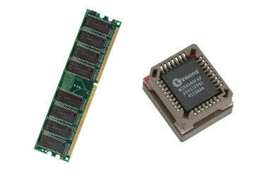

The two types of memory, can be also divided in two categories: **volatile** and **non-volatile**.

Their meaning will make more sense as we characterize **RAM** and **ROM.**

**RAM** is a form of data storage which can be accessed at any time and in a random mode and in any order from a physical location. Its name RAM stands for *Random Access Memory.*

**RAM**: - reads data bytes quick to run application;

- it allows reading and writing;

- RAM is **volatile** meaning that the content is lost as soon as the device is powered off.

As seen at the beginning of the paper, there are two types of RAM: **static** and **dynamic**.

**ROM** is a form of data that cannot be easily reprogrammed. Its name ROM stands for *Random Only Memory.*

**ROM**: - stores the program needed to boot the computer;

- it allows reading;

- ROM is **non-volatile** meaning that the content is retained even when the power is switched off.

**ROM** can be classified as: **PROM, EPROM** and **EEPROM**.

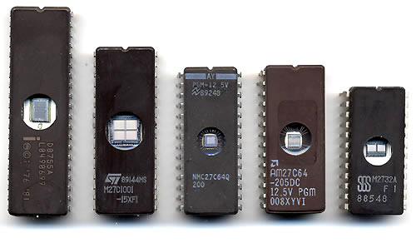 The PROM or the programmable ROM is a programmable ROM memory.

The EPROM or erasable PROM is a memory where the content can be changed in a specific moment.

The EEPROM or the electrically EPROM is a type of ROM memory that can be rewritten according to the instructions of the software.

The most commonly known memory, by a user, inside a computer is the **secondary memory**.

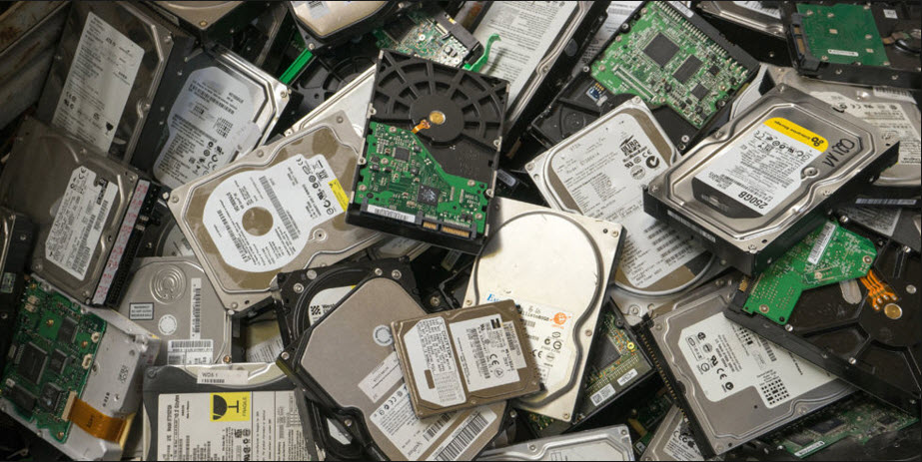

The **secondary memory** or the hard drive is a secondary memory type of storage. Every personal computer has a storage disk drive fitted inside the computer, that functions as the main memory of the computer. The secondary memory comes in diverse types and sizes.

Secondary storage differs from the primary memory by the simple fact that, secondary memory cannot be accessed directly by CPU (Central Processing Unit). The data is transferred from the second memory to the primary one and then accessed by the processor.

The characteristics of a secondary memory are:

- there are optical, magnetic and SSD (Solid State Drive);

- named usually as a backup memory;

- non-volatile;

- data is stored permanently until deletion;

- a computer can run without a secondary memory;

- it is slower compared to a primary memory;

- it is connected to the motherboard but not a part of it.

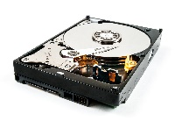 A secondary memory can be classified in:

**- Hard Drives;**

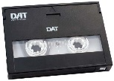

**- Tapes;**

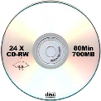

**- CD;**

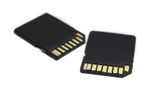

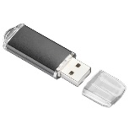 **- Flash Memory;**

**- USB Sticks;**

One important fact that makes the difference between types of storage is *access time.*  An access time represents the time frame in which a CPU can access a data from a storage type.

Acceding to the access time the secondary memory can be classified in to main forms:

- secondary memory with **sequential access;**

**-** secondary memory with a **direct access.**

On a storage with sequential access the information is stored in a line, meaning that the information is written one bit after another. To find the piece of information that you need the CPU needs to read bit by bit to locate the desired information. On a storage with direct access the data can be located anywhere on the disk without having to go through all the data bits to find a specific information.

A **Hard Disk** of a system, stores all the applications installed on the system and all the files that were created and used by the applications. It can be anything starting from a song to important documents. The hard disk is used for permanent storage, it is not a volatile type memory, meaning that once restarted the computer will have the data saved.

There are two types of computer hard drives:

-  **hard disk drives** or **HDD**;

- **solid state drives** or **SSD**.

The hard drive has been the predominant type of storage in a computer since the early days of computing.

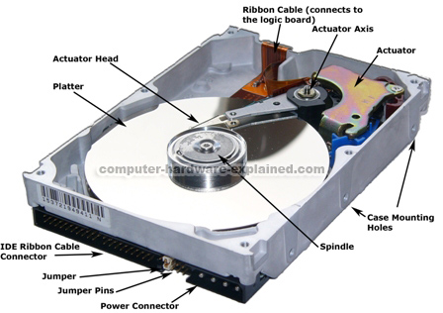

Looking at a hard drive from a constructive point of view, the hard drive’s motor is spinning the platter at a speed measured in revolutions per minute. The speed differs from one constructor to another. The spindle is rotating around the clock unless the hard drive is programmed to go into sleep mode.

Hard disks with fast spinning platters translate in fast hard drives. The revolution per minute or RPM has a significant impact on the overall speed. Common hard disks operate at 5,400 RPM and go all the way up to 10.000 RPM. In most desktop computers, the HDD is spinning at a standard 7.200 RPM. Some of the fastest hard drives have a speed of 15,000 RPM, there are not at the reach of the common user, mostly used as enterprise-level drives.

Sequential Performance Random Performance

5,400 RPM HDD 75 MB/s 65 IOPS

7,200 RPM HDD 100 MB/s 90 IOPS

10,000 RPM HDD 140 MB/s 140 IOPS

Higher RPM means a faster disk speed.

The actuator is used to position the head arms onto distinct tracks on the platter’s surface. The actuator is a very important piece, because changing from a track to another onto a platter is the only operation that requires any movement.

Once you acquire a hard disk, the part itself is not prepared to receive data. There are several steps that need completing to function at the desired standards. Manufacturers provide start up disk containing the utilities needed to prepare the disk for use.

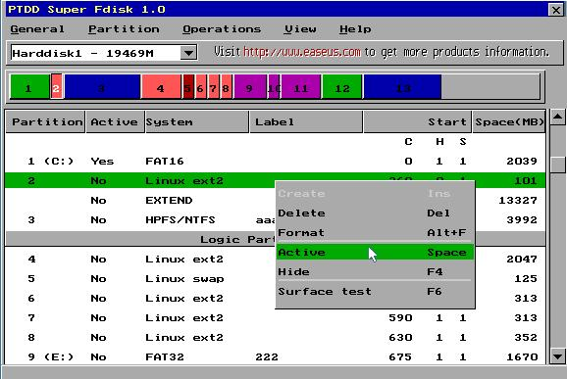

**FDISK** is one well known utility, it allows you to partition and **format** a hard drive and each partition will be given a drive letter. FDISK also creates a Master Boot record, used by BIOS (Basic Input/output System) to start up the unit.

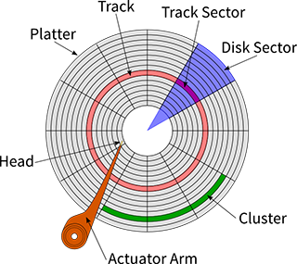To format a hard drive means placing the sectors and the tracks on the hard drive ready to receive data. After the formatting process the platters of the disk are divided into individual areas of TRACKS and SECTORS.

**Sector** - represents one section of a track.

**Track** – represent the concentric circle on the platter. The circles are smaller towards the center a larger towards the outer edge.

The major problem with a hard disk represents the moment when it breaks down. In that moment, you may lose all the data that you had on the hard disk. To avoid the loss of data, the data must be saved on a different memory device. The data can be stored on external hard disks or, on DVD’s or on memory sticks that plug in the computer via the USB socket. The only problem with the above mention gadgets is that you must back up your files each time you change or create one.

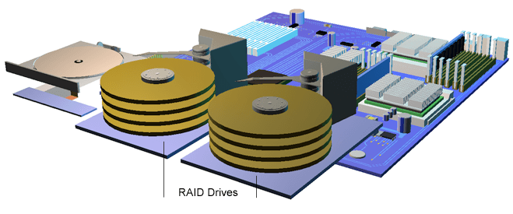

Many computers use a **RAID** system. A RAID system means having separate hard disks installed in the computer in the computer.

When the data is saved on the main hard drive it is also saved on a secondary disk drive installed on the computer. In this way, there will always be a copy of the data even if the main memory breaks down.

**Solid states drives** are a new alternative to a traditional hard disk. Solid state drives refer to an electric circuitry that is built entirely from semiconductors.

SSD’s do not have any moving parts and the data is stored electrically and not magnetic. Most SSDs use flash memory, memory that is also used in memory cards and USB flash drives. By not having a moving part a SSD is a lot less vulnerable to damage.

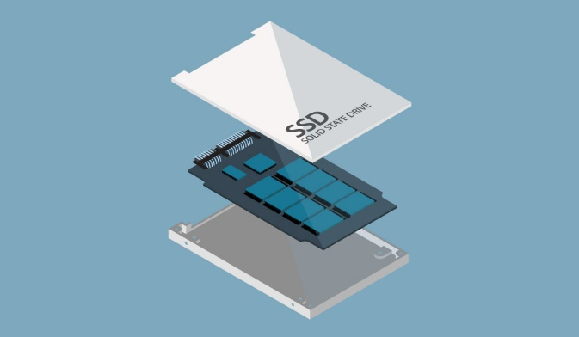The solid-state drives will quickly become the

preferred method of storage, despite the excessive cost, as they are nearly damage proof and they are quite minor compared to regular hard drives. Some solid-state drives are as small as a flash memory. Solid state drives and USB memory drives both use the same non-volatile memory. The only difference between the two is the form and the capacity of the drives.

The storage on a solid-state drive is handled by flash memory chips.

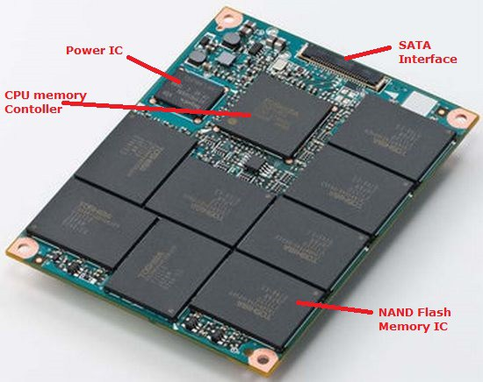 This provides three advantages:

- low power usage;

- fast data access;

- high reliability.

Low power usage makes it ideal for portable computers. Fast access of data makes the users happy. Reliability is a crucial factor for portable computers, the SSD stores all the data in memory chips and there are no moving parts that could be damaged in case of impact.

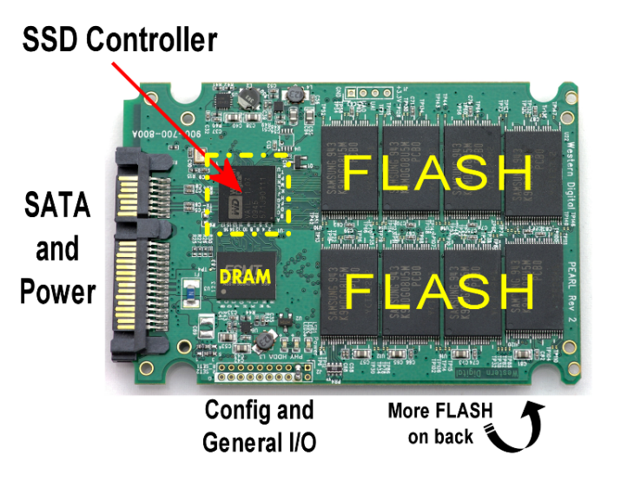

The main components of a solid-state drive are the memory to store the data and the controller. In the early construction of the SSD the primary memory was a DRAM volatile memory that has been replaced with a **NAND** non-volatile memory flash.

NAND flash has been created to reduce the cost and to increase the chip storage capacity to compete with magnetic storage devices. It has a finite number of write cycles and it wears out gradually. When the memory wears out the user buys another storage.

The controller of an SSD contains the electronic that connects the NAND memory to the host computer. The controller is a processor that executes firmware codes and is an important part of the SSD performance.

As functions performed by the controller we can name the following:

- Encryption;

- Read/Write catching;

- Error-correcting mode;

- Garbage collection.

The performance of an SSD relates to the number of NAND chips incorporated in the device. One NAND chip only is quite slow.

An SSD uses a low amount of DRAM as a catch and the data is not permanently stored in the catch. Another vital component in the performance of an SSD is a form of battery. A power source is necessary to maintain the integrity of the data so that the data inside the catch can be transferred to the drive when the power is switch off.

Considering the construction of an SSD, interconnected integrated circuits and an interface connector, the shape could be almost anything imaginable because it is no longer limited by rotating shape of the rotating platters.

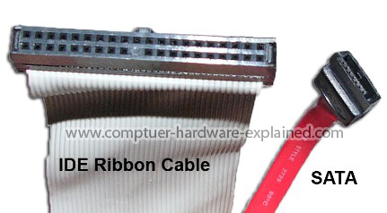 **IDE** and **SATA** are interfaces to connect storage device to the motherboard’s system bus. SATA stands for Serial Advanced Technology Attachment or Serial ATA and IDE is also called Parallel ATA.

SATA is the new standard and in the present, is the most commonly used. IDE has been used for many years and it is the least expensive interface used.

In 2007, the IDE ribbon has been replaced by SATA in all the new systems.

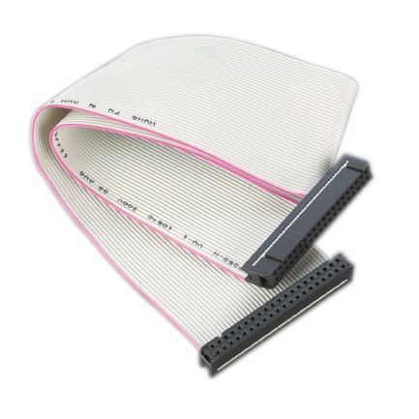

**IDE:** – has max compatibility;

- cannot support hot plugins;

- wide ribbon, 18 inches long;

- 133MB/s transfer rate;

- can connect more than one hard drive but the system does not know which is the one with the OS.

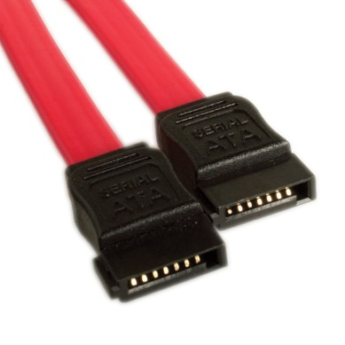

**SATA**: - large storage capacity;

- can support hot plugins;

- data transfer up to 6 Gb/s;

- length can reach up to 1 meter;

- SATA does not use jumpers.

**Recap:**

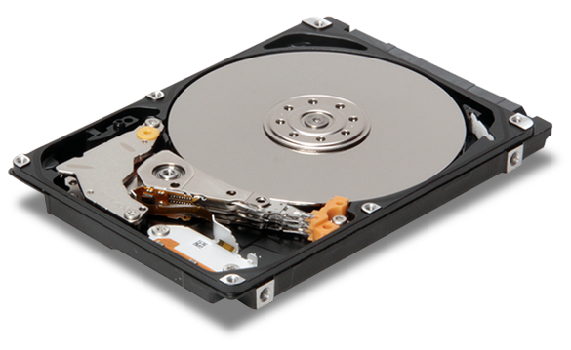 **HDD: -** high latency;

- long read/write times;

- supports fewer IOPs;

- use more electricity;

- need to be defragmented periodically;

- contains moving parts;

-HDD’s are heavier than SSD.

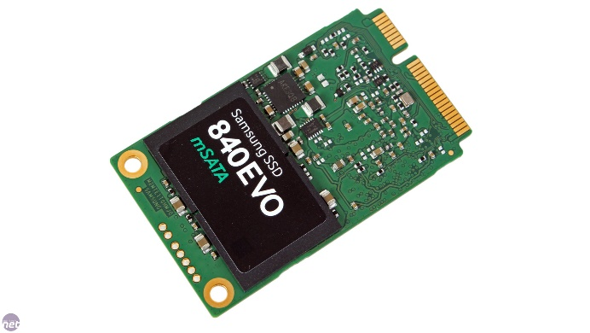 **SSD:** - low latency;

- fast read/write times;

- supports more IOP’s (input output operations per second)

- use less power and do not generate hear;

- defragmentation is not necessary;

- no moving parts;

- can withstand vibrations.

**Conclusions:**

Customers expect that the data store on a SSD or a Hard Drive will always be there no matter the conditions like the loss of power, temperature, shock. Customers also expect that storage will be low cost. All the users seek high performance systems. The adoption of the SSD will continue to grow. The developer must set a set of standards to set the expectations of the drive and increase the customer satisfaction.

**Bibliography**

Bing.com. (2017). *fdisk images - Bing images*. [online] Available at: https://www.bing.com/images/search?view=detailV2&ccid=fd99yfZm&id=AE243C9067746533BC918560150AF67F3134493F&thid=OIP.fd99yfZmsAvZbnNon7_LdgEsDI&q=fdisk+images&simid=608050603283516603&selectedIndex=6&ajaxhist=0 [Accessed 3 May 2017].

Bing.com. (2017). *Flash Memory Card - Bing images*. [online] Available at: https://www.bing.com/images/search?view=detailV2&ccid=fOePP1Gf&id=3E217668EE6ACCBC61CEEF41EC5D08F2D71EC929&thid=OIP.fOePP1GfgEmQXlBjuDrL0wEsCo&q=Flash+Memory+Card&simid=607991036384053065&selectedIndex=2&ajaxhist=0 [Accessed 2 May 2017].

Bing.com. (2017). *hdd pictures - Bing images*. [online] Available at: https://www.bing.com/images/search?view=detailV2&ccid=8RFe6cUs&id=D9DE3B2E2C0C947A8505CF0A4435402BB5317066&thid=OIP.8RFe6cUs3CrqKDYXHZV7SwEsC4&q=hdd+pictures&simid=608056186744734353&selectedIndex=28&ajaxhist=0 [Accessed 4 May 2017].

Bing.com. (2017). *ide - Bing images*. [online] Available at: https://www.bing.com/images/search?view=detailV2&ccid=AyGr%2fC0G&id=929C97416D6B1FED678CE2273E55F49D8B7BABDD&thid=OIP.AyGr_C0GiV097jGLTOa1xgEsEs&q=ide&simid=608044775017025156&selectedIndex=2&ajaxhist=0 [Accessed 4 May 2017].

Bing.com. (2017). *images for harddisks - Bing images*. [online] Available at: https://www.bing.com/images/search?view=detailV2&ccid=FbDuXFRX&id=A8711B236DC66B47F0C16771889A45C40FB70B56&thid=OIP.FbDuXFRXakYPNvM5mv6QXQEsDT&q=images+for+harddisks&simid=608052828083325970&selectedIndex=22&qpvt=images+for+harddisks&ajaxhist=0 [Accessed 2 May 2017].

Bing.com. (2017). *images for harddrive - Bing images*. [online] Available at: https://www.bing.com/images/search?view=detailV2&ccid=9UlO4tyV&id=D94F7A1D30486F3FC8E1E5D02B0187264FA0775E&thid=OIP.9UlO4tyVrywAu3KUvipEmQEsDh&q=images+for+harddrive&simid=608011892743995503&selectedIndex=1&ajaxhist=0 [Accessed 2 May 2017].

Bing.com. (2017). *images for magnetic tape - Bing images*. [online] Available at: https://www.bing.com/images/search?view=detailV2&ccid=77fwnyBs&id=843A9FD8201163C154E8CB2FD5621770168F5189&thid=OIP.77fwnyBsIRnSAWvSEDIkNgEsDU&q=images+for+magnetic+tape&simid=608001563356299795&selectedIndex=56&ajaxhist=0 [Accessed 2 May 2017].

Bing.com. (2017). *images for sata and ide - Bing images*. [online] Available at: https://www.bing.com/images/search?view=detailV2&ccid=09jN7za0&id=2EBEAB6C6B66978A747F91BCDD976669A510B7ED&thid=OIP.09jN7za0fxexgTqfH4B3CgEsCl&q=images+for+sata+and+ide&simid=607989799428427465&selectedIndex=3&ajaxhist=0 [Accessed 4 May 2017].

Bing.com. (2017). *images of catch memory - Bing images*. [online] Available at: https://www.bing.com/images/search?view=detailV2&ccid=xBcaiueZ&id=DA46F56A3EC9434AE58F1796D1DFC62EC30BF6E4&thid=OIP.xBcaiueZviaUoKel7_IpcwEsEs&q=images+of+catch+memory&simid=608014736003630150&selectedIndex=6&ajaxhist=0 [Accessed 1 May 2017].

Bing.com. (2017). *images of ram and rom - Bing images*. [online] Available at: https://www.bing.com/images/search?view=detailV2&ccid=9LsKWSHy&id=29C8CF4D6A29BC2F50B9DD3C7BFB100742BB882B&thid=OIP.9LsKWSHyi3elw-589R1pcwEsDh&q=images+of+ram+and+rom&simid=608045638296274002&selectedIndex=16&ajaxhist=0 [Accessed 1 May 2017].

Bing.com. (2017). *images of ram and rom - Bing images*. [online] Available at: https://www.bing.com/images/search?view=detailV2&ccid=ymU4x9FA&id=032A657E712016DEA7F184F12C61C57BB4ADE75D&thid=OIP.ymU4x9FAmQUjHO3mCcs6eQEsDM&q=images+of+ram+and+rom&simid=607989387113663413&selectedIndex=8&ajaxhist=0 [Accessed 1 May 2017].

Bing.com. (2017). *nand flash memory - Bing images*. [online] Available at: https://www.bing.com/images/search?view=detailV2&ccid=MyeVFAyM&id=B94073CE26A9191BE5551C6F5693EB06FC2D0B7A&thid=OIP.MyeVFAyM4wGTnVGx3XO15gEsCs&q=nand+flash+memory&simid=608039260295200884&selectedindex=52&mode=overlay&first=1 [Accessed 4 May 2017].

Bing.com. (2017). *prom eprom eeprom - Bing images*. [online] Available at: https://www.bing.com/images/search?view=detailV2&ccid=9IEJWUSk&id=B9167FA096DC214705EBFC0C0474B6F116CC1A1A&thid=OIP.9IEJWUSkfj27vbNH4V30rAEsCy&q=prom+eprom+eeprom&simid=608044263918534995&selectedIndex=121&ajaxhist=0 [Accessed 2 May 2017].

Bing.com. (2017). *prom eprom eeprom - Bing images*. [online] Available at: https://www.bing.com/images/search?view=detailV2&ccid=LA8sD7EI&id=FAEB3512CF1F49FB5960D91957B7DCE32725B70E&thid=OIP.LA8sD7EISxHeVx3lDXzOGwEsDh&q=prom+eprom+eeprom&simid=608018330903514367&selectedIndex=125&ajaxhist=0 [Accessed 2 May 2017].

Bing.com. (2017). *sata - Bing images*. [online] Available at: https://www.bing.com/images/search?view=detailV2&ccid=s5QNJXdS&id=1E56DBFFE5D21ED27D6921E609832F6CF316003F&thid=OIP.s5QNJXdSwT976nq2cnkQigEsEs&q=sata&simid=608011733816509247&selectedIndex=3&ajaxhist=0 [Accessed 4 May 2017].

Bing.com. (2017). *solid state drive - Bing images*. [online] Available at: https://www.bing.com/images/search?view=detailV2&ccid=al4GcjMg&id=116CB575936867D439779D48DB3C291EC6898A65&thid=OIP.al4GcjMgb2iJjqyHECE_vAEsCv&q=solid+state+drive&simid=608024232178225061&selectedIndex=11&ajaxhist=0 [Accessed 3 May 2017].

Bing.com. (2017). *SSD pictures - Bing images*. [online] Available at: https://www.bing.com/images/search?view=detailV2&ccid=oFVshmv9&id=60470067F0619999972549456D0A998B4936BAB0&thid=OIP.oFVshmv9EZ4mElOBwFFd_gEsCo&q=SSD+pictures&simid=608006717314697850&selectedIndex=8&ajaxhist=0 [Accessed 4 May 2017].

Bing.com. (2017). *tracks and sectors o n a hard disk - Bing images*. [online] Available at: https://www.bing.com/images/search?view=detailV2&ccid=B2PogTbF&id=4E5A8BCA29A2D7C546638F06580E6BCE1663F91A&thid=OIP.B2PogTbFEan5PEnOPoQ2DwEsEL&q=tracks+and+sectors+o+n+a+hard+disk&simid=608011020864325131&selectedIndex=6&ajaxhist=0 [Accessed 3 May 2017].

Bing.com. (2017). *usb memory stick - Bing images*. [online] Available at: https://www.bing.com/images/search?view=detailV2&ccid=Ff97DCKF&id=A86127D13D62A799D8D52C41E03659D6AAC4626C&thid=OIP.Ff97DCKFus4QJBGSut2kZQEsEs&q=usb+memory+stick&simid=608046188053335568&selectedIndex=9&ajaxhist=0 [Accessed 2 May 2017].

Lifewire. (2017). *Do You Need a Solid State Drive (SSD) for Your PC?*. [online] Available at: https://www.lifewire.com/solid-state-drive-833448 [Accessed 4 May 2017].

Recoverydataharddisk.com. (2017). *Cite a Website - Cite This For Me*. [online] Available at: http://www.recoverydataharddisk.com/image-slide/66.jpg [Accessed 2 May 2017].

Study.com. (2017). *What Is a Hard Drive? - Types, Function & Definition - Video & Lesson Transcript | Study.com*. [online] Available at: http://study.com/academy/lesson/what-is-a-hard-drive-types-function-definition.html [Accessed 2 May 2017].

Study.com. (2017). *What Is a Hard Drive? - Types, Function & Definition - Video & Lesson Transcript | Study.com*. [online] Available at: http://study.com/academy/lesson/what-is-a-hard-drive-types-function-definition.html [Accessed 2 May 2017].

Us, A. (2017). *The Development and History of Solid State Drives (SSDs)*. [online] Semiconductorstore.com. Available at: http://www.semiconductorstore.com/blog/2014/The-Development-and-History-of-Solid-State-Drives-SSDs/854 [Accessed 4 May 2017].

Watson, A. (2017). *Hard Disk Construction*. [online] Tecks.co.uk. Available at: http://tecks.co.uk/technicians/harddrives/harddiskconstruction.html [Accessed 3 May 2017].

Webopedia.com. (2017). *What is Memory? Webopedia Definition*. [online] Available at: http://www.webopedia.com/TERM/M/memory.html [Accessed 1 May 2017].

WhatIs.com. (2017). *What is NAND flash memory ? - Definition from WhatIs.com*. [online] Available at: http://whatis.techtarget.com/definition/NAND-flash-memory [Accessed 4 May 2017].

www.tutorialspoint.com. (2017). *Computer Read Only Memory*. [online] Available at: https://www.tutorialspoint.com/computer_fundamentals/computer_rom.htm [Accessed 1 May 2017].